

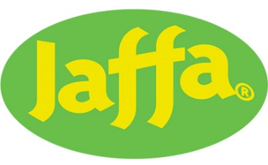
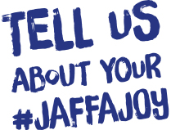
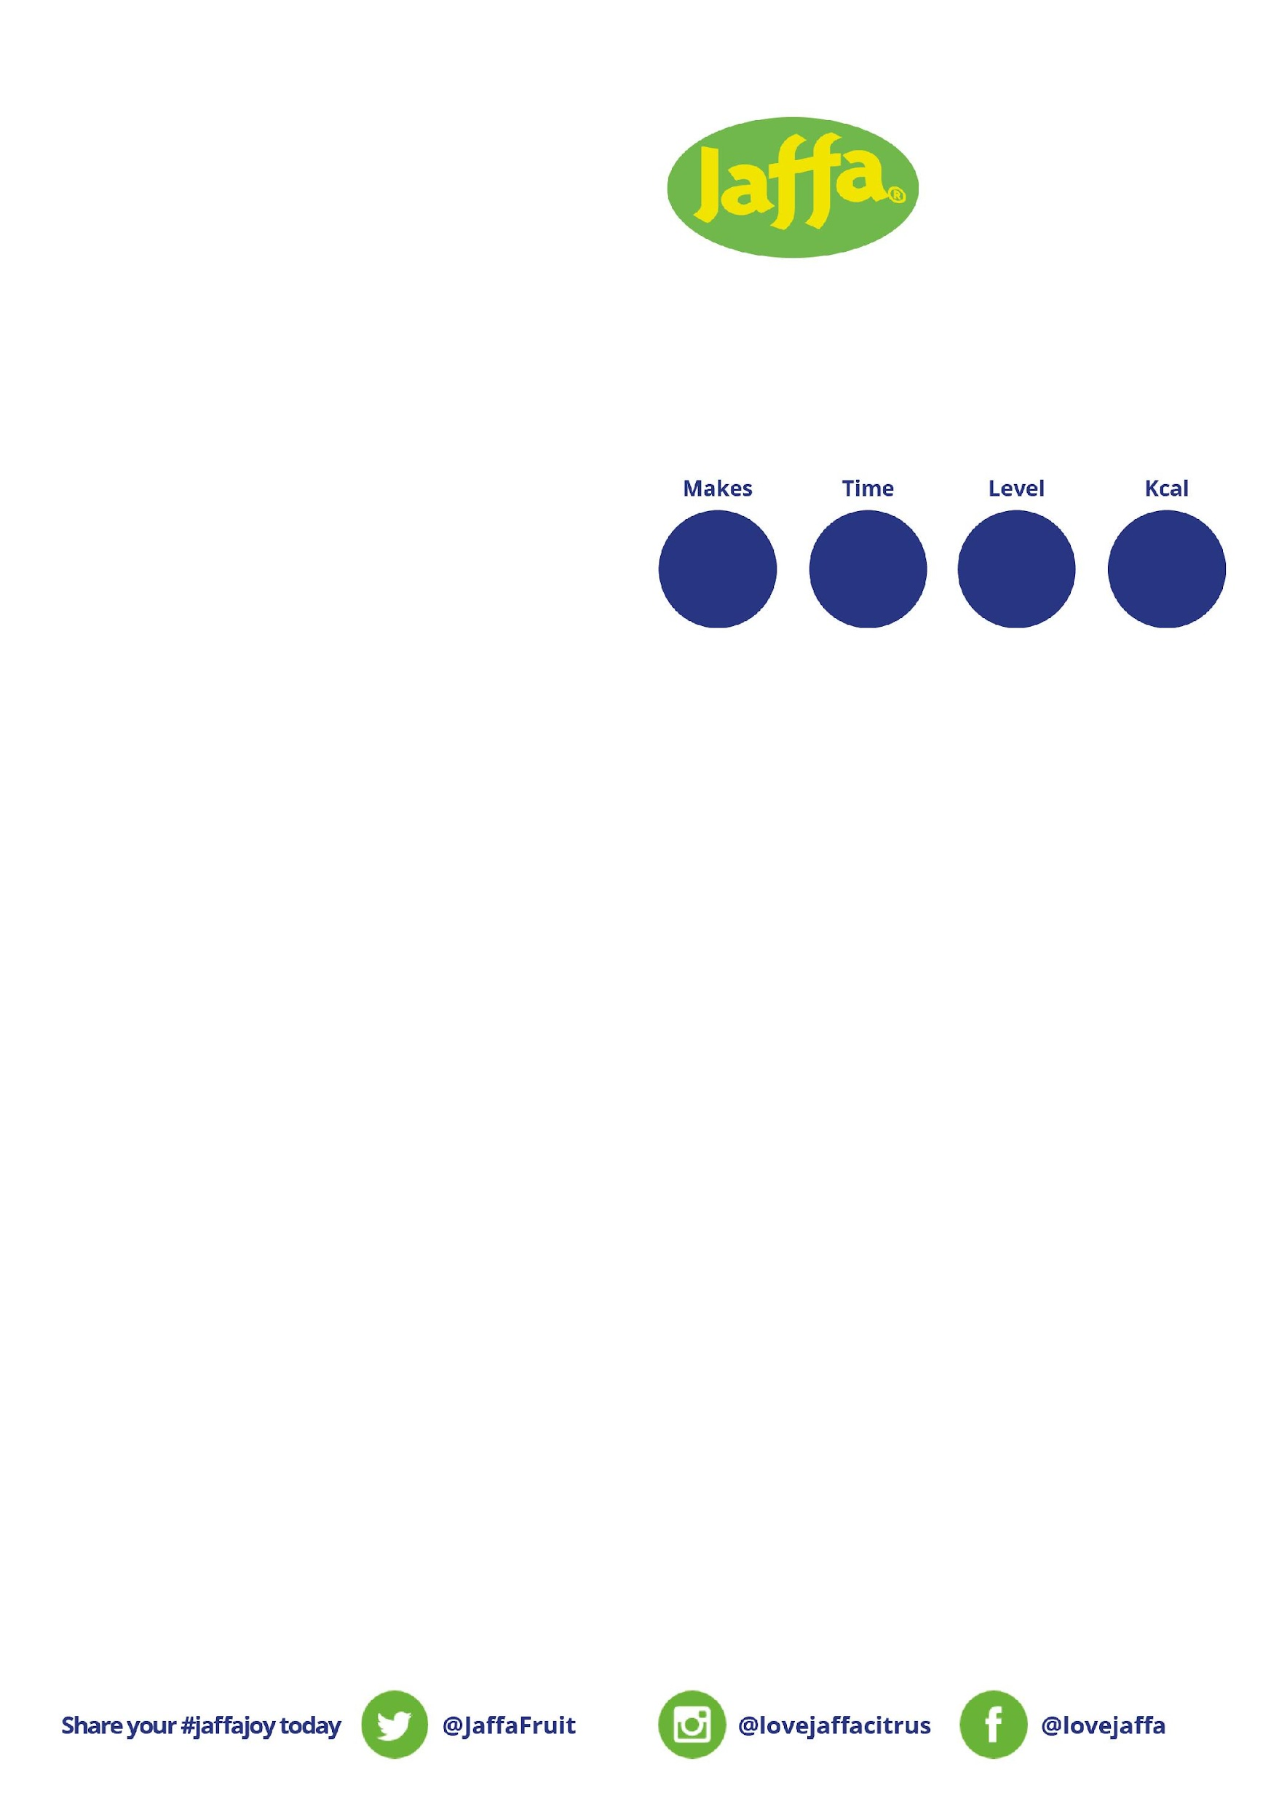
90
24
Our step-by-step guide
Step 1
Soak the Medjool Dates in hot water (use enough water to just cover the dates) for ten minutes.
Step 2
Once the Medjool Dates have soaked, place them in a blender and blitz to a paste, adding small splashes of their soaking water until you’re done. Then set aside.
Step 3
Stir together the Pecans, Jaffa Juicy Orange zest and spices until combined. Fold in the date paste, dried fruit and a squeeze of Jaffa Juicy Orange juice.
Step 4
Roll the mixture into balls (you can add a drizzle of maple syrup for a sweeter hit, if desired), adding more ground almonds if the mix is too sticky. Then chill for 20 minutes.
Step 5
Melt the white chocolate with coconut oil, then drizzle over each energy ball. Decorate with edible holly sprinkles.
Step 6
Enjoy!
You will need
2 x Jaffa Juicy Oranges, zested and juiced
1 x Cup of Pecans, grounded to flour
1 x Cup of Medjool Dates, pitted
½ x Cup Almonds, grounded
1 x Large Handful of Dried Fruit
1 x Pinch of Nutmeg
1 x TSP Vanilla
1 x TSP Ground Cinnamon
¼ x TSP Ginger (or more, to taste)
Optional: Maple Syrup if you like it sweeter
For Decorating:
100g x White Chocolate
1 x TSP Coconut Oil
Edible Holly Sprinkles

JAFFA ORANGE CHRISTMAS PUDDING ENERGY BITES
per portion n
15
minutes
Simple

